Position Information
Below is the Roles and Responsibilities for the Community Health Director position as well as the Nominations and Elections North Director position. If you have any questions, please email presidentians@gmail.com

Community Health Director
Roles and Responsibilities:
- Increase the number of disaster prepared nursing students.
- Promote national disaster preparedness and relief programs to state members.
- Organizes programs to improve community health across state.
- Work closely with the Image of Nursing Director in coordinating events for state members

Nominations and Elections North Director (NEC)
Roles and Responsibilities:
- Recruiting nursing students for the upcoming IANS election
- On the day of the IANS Annual Convention, both NEC’s are responsible for running the Delegate Meeting in which the next IANS BOD will be elected
- Work closely with the Membership North & South Directors to increase IANS Awareness across the state
- Aide Membership Directors in increasing the number of Indiana colleges on the Total School Membership Plan

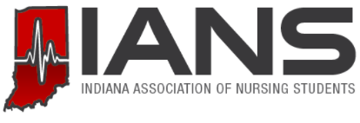
BOARD OF DIRECTORS APPLICATION 2019-2020

NAME:
UNIVERSITY:
IANS POSITION/ POSITIONS OF INTEREST:
YEAR IN SCHOOL:
EMAIL:
CELL PHONE #:
NSNA MEMBERSHIP # (must be an NSNA member to run for office):

Prompt describing why you feel you should be selected as an IANS Board Member for the 2020-2021 term:

Email completed application to Kasi (presidentians@gmail.com) by November 8th!

